
UNDERGRADUATE SENIOR PROJECT REPORT
Type/paste the title of the project here, capitalize the first letter of each word only

by
Firstname Lastname (Team Leader)
Firstname Lastname
Firstname Lastname
Firstname Lastname

Sichuan University - Pittsburgh Institute
[Term YEAR]
Copyright in this work rests with the authors. Please ensure that any reproduction
or re-use is done in accordance with the relevant national copyright legislation.

Declarations
Project Team Members
Role | Student Name | Student ID | Major
Team Leader
Team Member
Team Member

Advisory Committee Members
 | Name | Department/Affiliation
Advisor
Co-Advisor
Outside major faculty
Non-tech Major faculty

声 明
本人声明所呈交的学位论文是本人在导师指导下进行的研究工作及取得的研究成果。据我所知，除了文中特别加以标注和致谢的地方外，论文中不包含其他人已经发表或撰写过的研究成果，也不包含为获得四川大学或其他教育机构的学位或证书而使用过的材料。与我一同工作的同志对本研究所做的任何贡献均已在论文中作了明确的说明并表示谢意。
本学位论文成果是本人在四川大学读书期间在导师指导下取得的，论文成果归四川大学所有，特此声明。

作者手写签名：
导师手写签名：
年 月 日

学位论文使用授权书
本学位论文作者完全了解四川大学有关保留、使用学位论文的规定，同意学校保留并向国家有关部门或相关机构送交论文的原件、复印件和电子版，允许论文被查阅和借阅。本人授权四川大学将本学位论文的全部或部分内容编入有关数据库进行信息技术服务，可以采用影印、缩印或扫描等复制手段保存、汇编学位论文，并用于学术活动。
（涉密学位论文在解密后适用于本授权书）

作者手写签名：
导师手写签名：
年 月 日
贡献度说明
Each member’s contribution

Advisor’s comments

四川大学本科毕业论文 AI 工具使用声明​

本人声明，在撰写题目为《[毕业论文题目]》的本科毕业论文过程中，对 AI 工具的使用情况如下：​
一、使用的 AI 工具及使用目的​
序号 | AI工具 | 使用目的
1 | 列举使用的具体 AI 工具，如 ChatGPT、文心一言等 | 详细说明使用该工具的具体用途，例如语言润色、资料检索辅助、数据分析建议等
2
…… | …… | ……
二、使用程度说明​
序号 | 章节 | AI工具 | 使用方式 | 内容占比(%) | 处理方式
1 | 具体章节或部分，如摘要、引言、正文某章节等 | 上述 AI 工具 | 具体操作，如输入特定问题获取回答、利用工具的特定功能进行文本处理等 | [X] | 详细说明后续处理方式，如筛选、修改、重新组织语言、结合自身研究进行调整等
2
…… | …… | …… | …… | …… | ……
在论文的 [具体章节或部分，如摘要、引言、正文某章节等] 使用了上述 AI 工具。使用方式为 [具体操作，如输入特定问题获取回答、利用工具的特定功能进行文本处理等]。在这些部分，AI 工具提供的内容占比约为 [X]%。​
本人对 AI 工具提供的内容进行了 [详细说明后续处理方式，如筛选、修改、重新组织语言、结合自身研究进行调整等]，以确保论文内容符合学术要求及本人的研究思路。​
三、原创性与责任声明​
本人确认，尽管使用了上述 AI 工具，但论文整体的研究思路、核心观点、论证过程及最终结论均为本人独立思考与研究的成果。论文中引用 AI 工具生成内容之处，均已按照学校规定的学术规范进行了明确标注。​
若论文因 AI 工具使用不当或未按要求标注等原因出现学术不端问题，本人愿意承担全部责任。​

学生签名：
指导老师签名：​
年 月 日

Abstract
Abstract paragraphs should be unindented: use the style 1_Para_FlushLeft.
Abstracts are recommended to limit the word count to 350 words or less. Abstract text must fit on a single page. Keywords may appear alone on a second page.
You may include up to six keywords or phrases. Keywords should be separated with semicolons.
Keywords: thesis template; Microsoft Word; keywords; 1” hanging indent; instructions

中文摘要
Abstract paragraphs should be unindented: use the style 1_Para_FlushLeft.
Abstracts are recommended to limit the word count to 350 words or less. Abstract text must fit on a single page. Keywords may appear alone on a second page.
You may include up to six keywords or phrases. Keywords should be separated with semicolons.
关键词：thesis template；Microsoft Word；keywords；1” hanging indent；instructions

Dedication
This is an optional page. Use your choice of paragraph style for text on this page (1_Para_FlushLeft shown here).
To hide the heading at the top of this page, select the text and change the text colour to white.

Acknowledgements
This is an optional page. Use your choice of paragraph style for text on this page (1_Para shown here).

Table of Contents
Declarations ii
Abstract iii
Dedication iv
Acknowledgements v
Table of Contents vi
List of Tables vii
List of Figures viii
List of Acronyms ix
Glossary x
Preface/Executive Summary/Image xi
Chapter 1. Introduction 1
1.1. Create A Table and Add Caption 1
References 3
Appendix A. An Example of an Appendix 4

List of Tables
Table 1-1 Comparison of Performance Statistics of Three Great NBA Players 1

Use References>Insert Caption to create caption labels and numbers. Right-click on the text above and select Update Field to update this list. See the SCUPI Thesis Template Instructions for information on creating tables, figures, and captions.
Remember to delete this note before submission.
If there are no tables in the document, remove this page.

List of Figures
Figure 1-1 Add Chapter Number to Table Number 2

Use References>Insert Caption to create caption labels and numbers. Right-click on the text above and select Update Field to update this list. See the SCUPI Thesis Template Instructions for information on creating tables, figures, and captions.
Remember to delete this note before submission.
If there are no figures in the document, remove this page.

List of Acronyms
RMB | Right Mouse Button
SCUPI | Sichuan University – Pittsburgh Institute
ASME | American Society of Mechanical Engineers
 | This is an optional page and can be removed if not used.
 | Use one table row for each item to allow sorting using Word’s table tools.
 | RMB-click Insert>Insert Row Above/Below to add more rows to the listing.
 | Apply the style 1_Para_NoSpace to table rows as shown here.

Glossary
Thesis | An extended research paper that is part of the final exam process for a graduate degree. The document may also be classified as a project or collection of extended essays.
Glossary | An alphabetical list of key terms
 | This is an optional page and can be removed if not used.
 | Use one table row for each item to allow sorting using Word’s table tools.
 | RMB-click Insert>Insert Row Above/Below to add more rows to the listing.
 | Apply the style 1_Para_NoSpace to table rows as shown here.

Preface/Executive Summary/Image
This page can be used for a Preface, Executive Summary, or introductory image. This is an optional page and can be deleted if not used.
To hide the heading at the top of this page – e.g., if using an introductory image – select the text and change the text colour to white.
Do not delete the section break that follows this paragraph. If the section break is not visible, turn on non-printing characters using the Show/Hide icon (¶) on the Home ribbon.

Introduction
This is the beginning of chapter one.

Create A Table and Add Caption
A new table is created here. Number of rows and columns of the table is specified by Insert>Table. Statistics of three great NBA players from their best seasons are tabulated for comparison.
The first row of the table is the heading of the players’ statistics. After filling in the information, the headings in row 1 are selected and formatted with style 3_TableHeading_Center. Data in the remaining table cells are formatted using style 3_TableData_Center.
To add the table caption, first select the whole table, go to References>Insert Caption, fill in the table title in caption cell, and click the OK button. At last, click anywhere over the caption and apply style 3_CaptionAbove to format it.
Table 1-1 Comparison of Performance Statistics of Three Great NBA Players
Player and Season | Points per Game | Assists per Game | Rebounds per Game
Jordan 89-90 | 33.6 | 6.3 | 6.9
Koby Bryant 05-06 | 35.4 | 4.5 | 5.3
Larry Bird 87-88 | 29.9 | 6.1 | 9.2

Text after the table begins here.
To modify any dimension of the table, such as column width or row height, etc., it is recommended to make the changes through Table Properties. Through Table Properties, we also recommend placing the table at the center of the page.
The above table also demonstrates that you can incorporate chapter number as part of the table number. It is up to you to decide which is the better way to present your work. To do so, however, after clicking the Numbering button in the Caption window, just simply check-marking the Include chapter number option as shown in Figure 1-1 below.
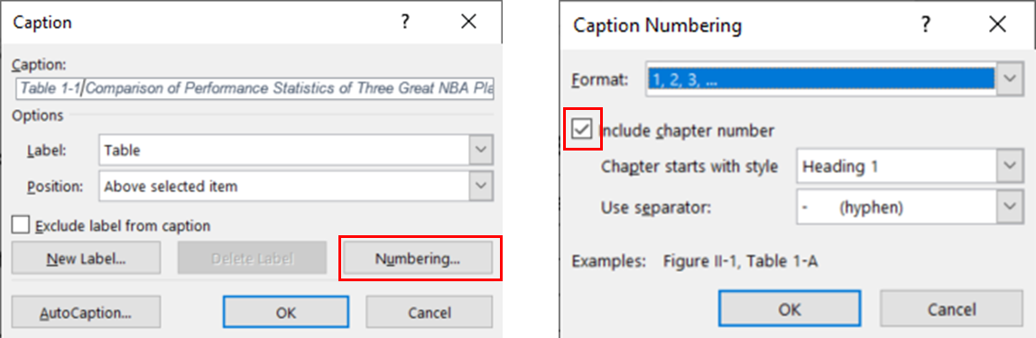
Figure 1-1 Add Chapter Number to Table Number
Caption of Figure 1-1 is added the same way as the table caption. The style 3_CaptionBelow is then used instead to format the figure caption.

References
Adams, Alice. (2002). Article Titles : A Qualitative and Quantitative Analysis. Journal of Journal Studies, 23, 189-672. doi:10.1015/0032-002X.56.7.893
Brown, Bob. (2010). Books: Sustainable and Biodegradable Reading Technology. New York, NY: Hydraulic Press. doi:10.1026/0022-005X.52.6.803
Carroll, Carol. (1999, July). Curating Curious Collections: An Interdisciplinary Perspective. Predatory Publishing Quarterly, 16 (5), 3-134.

Appendix A.
An Example of an Appendix

